**Guided Capstone Project 1 Report**

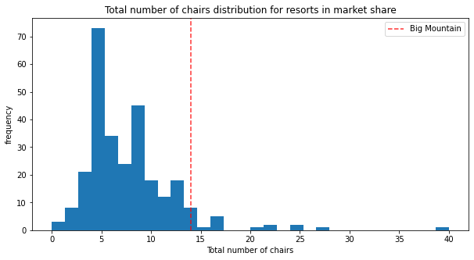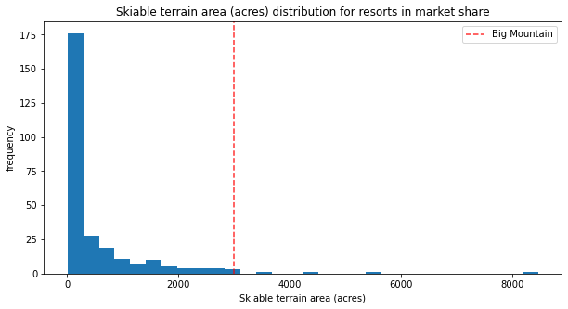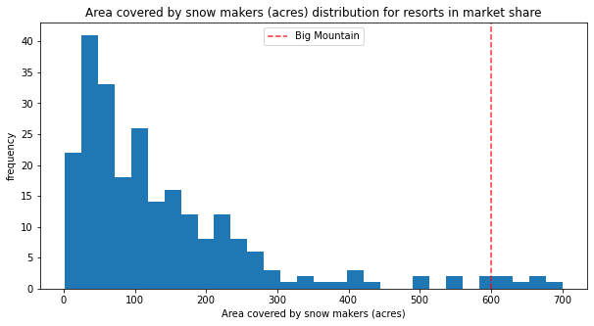 **Tasked with building a predictive model for pricing for Big Mountain Resorts (BMR), we have analyzed that Big Mountains Resorts could be profiting more from their ticket prices as they are currently being sold at $81 for Weekend and Weekday. With our predictive model we estimate that BMR can charge $95.87, while comparing BMR competition we see other resorts are charging much more while compared to BMR even though they rank in the upper echelon for the top 8 features for instances, we can see BMR has one the most snow making area, while most resorts fall far behind BMR. They also have more total chairs than other resorts. Similar pattern follows with the other key features like Fast Quads, Runs, Longest Runs, Trams, and Total Skiable Area.**

**Furthermore, we believe increasing the vertical drop by 150 feet and adding additional chair lift might yield a price increase of $1.99, that’s over $3 million in revenue while the operating costs would increase we know installing a new chair lift would yield to roughly $1.54 million in costs but this still nets us a profit of $1.4 million.**